Oscar Esparza Jose L. Muñoz Juanjo Alins Jorge Mata

SIP
UPC Network Engineering Department

Contents
- SIP 5
  - Practices 5
    - Basics of SIP 5
    - SIP with Proxies 13

Chapter 1
SIP

Practices

Basics of SIP

Scenario
The objective of this lab session is to put you in touch with the basic concepts of SIP signaling. The scenario you are going to use is depicted in Figure 1.1. Prior to start with the session, it is strongly recommended to have some knowledge about the DNS (Domain Name System), SDP (Session Description Protocol), RTP (Real Time Protocol) and RTCP (Real Time Control Protocol).
DNS
alice.example.com
203.0.113.2
203.0.113.4
eth1
bob.example.com
eth1
eth1
SW0
203.0.113.1
SimNet0
Linphone
203.0.113.3
203.0.113.0/24

phyhost

Figure 1.1: Scenario for the SIP lab session

To start the scenario execute in the HOST machine:
HOST$ simctl sip-basic start

Direct call between pjsua clients

Exercise 1.1– In this exercise you are going to make a direct call (no intermediaries) between alice and bob using the application pjsua. You will capture the traffic using wireshark to analyze the basics of the SIP signaling.
Notice that the calling user alice has to know, at least, the IP address (or DNS name) of the callee user bob. By
default, pjsua sends SIP packets using UDP as transport protocol and port number 5060, but as you will see, this port number can be changed. RTP and RTCP also use UDP, but the port numbers are generally announced in the session establishment.

- Execute in alice the following command:
alice:~# pjsua --null-audio --local-port=5060
This command opens the SIP client (calling party). In this particular case the option --local-port is unnecessary as you are going to use the default port, but now you know how to change the value of this port.
- Into the subshell of pjsua in alice, set the codec priority (Cp) to the value 200 for the PCMA codec. This will make this codec to be the first option to choose.
>>>Cp
Codec name ("*" for all) and priority: PCMA/8000 200
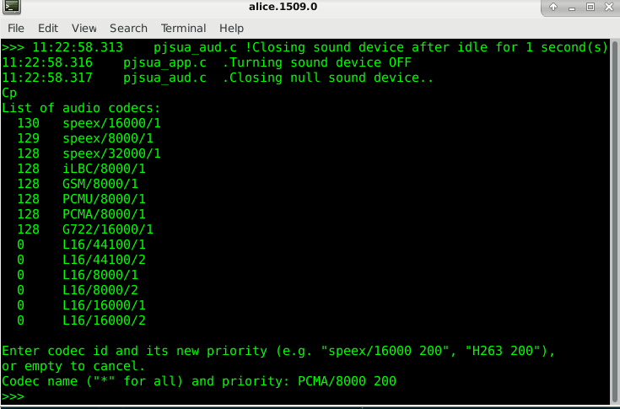
Most of the calls you will make are between virtual machines. Our virtual machines have no input/output devices for audio (there are no headphones or speakers in the virtual machines). So, you will use wireshark to “listen” to these conversations. The problem is that wireshark does not properly decodify the default codec speex, and for this reason we transmit using the PCMA codec, which is properly decodified by wireshark.
- Start pjsua in bob (callee party) with the following options:
bob:~# pjsua --play-file /root/hello16000.wav --auto-answer 180 --auto-play --local-port=5000 --null-audio
This command configure pjsua to answer automatically (-auto-answer option) with code 180 (which corre- sponds to “Ringing“), and to play directly the audio file /root/hello16000.wav when accepting the call. Also, in bob you are going to listen to local port 5000, not by the default SIP port (5060).
- Open wireshark to listen to SimNet0.
- Call bob from alice using option m and introducing the URI of bob:
>>> m
(You currently have 0 calls) Buddy list:
-none-

Choices:
0 For current dialog.
-1 All 0 buddies in buddy list [1 - 0] Select from buddy list
URL An URL
<Enter> Empty input (or 'q') to cancel Make call: sip:bob@bob.example.com:5000
Notice that instead of the DNS name, you can also use bob’s IP address (sip:bob@203.0.113.3:5000).
- Accept the call in pjsua of bob by typing “a”, and answering with a 200 code (OK):
Press a to answer or h to reject call
a
Answer with code (100-699) (empty to cancel): 200

- Wait for 10 seconds approximately, and finish the call by typing “h” in any of the two virtual machines. As we mentioned previously, you did not listen anything because virtual machines do not have any input/output device. Later you will use wireshark and the traffic capture to listen it.
- Stop the capture of wireshark and let us analyze the traces:
      - How many packets there are in the traces?

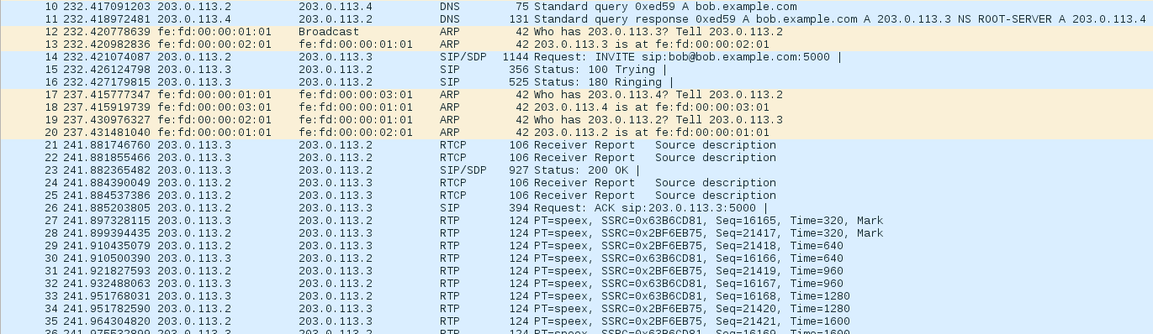
Total: A LOT OF THEM
- DNS: 2 One query from Alice to DNS & One query response from DNS to Alice
- SIP/DNS: 2 → 1 Request: INVITE from Alice to BOB 1 Status 200 OK
- RTCP: 4 + 13 Packets → Receiver/Sender Reports
- SIP:
  - Beginning: 3 packets: STATUS 100 Trying - Ringing - Request: ACK sip:203.0.113.3:5000
  - End: 2 packets: Request: BYE sip:203.0.113.2:5060;ob - Status: 200 OK
RTP: All the others, data ….
ARP: 8 → 4 at the beginning, 2 in the middle, and 2 at the end when closing the connection
Conference: A multimedia conference is a set of two or more communicating users along with the software they are using to communicate.
Session: A multimedia session is a set of multimedia senders and receivers and the data streams flowing from senders to receivers. A multimedia conference is an example of a multimedia session.
Session Description: A well-defined format for conveying sufficient information to discover and participate in a multimedia session.

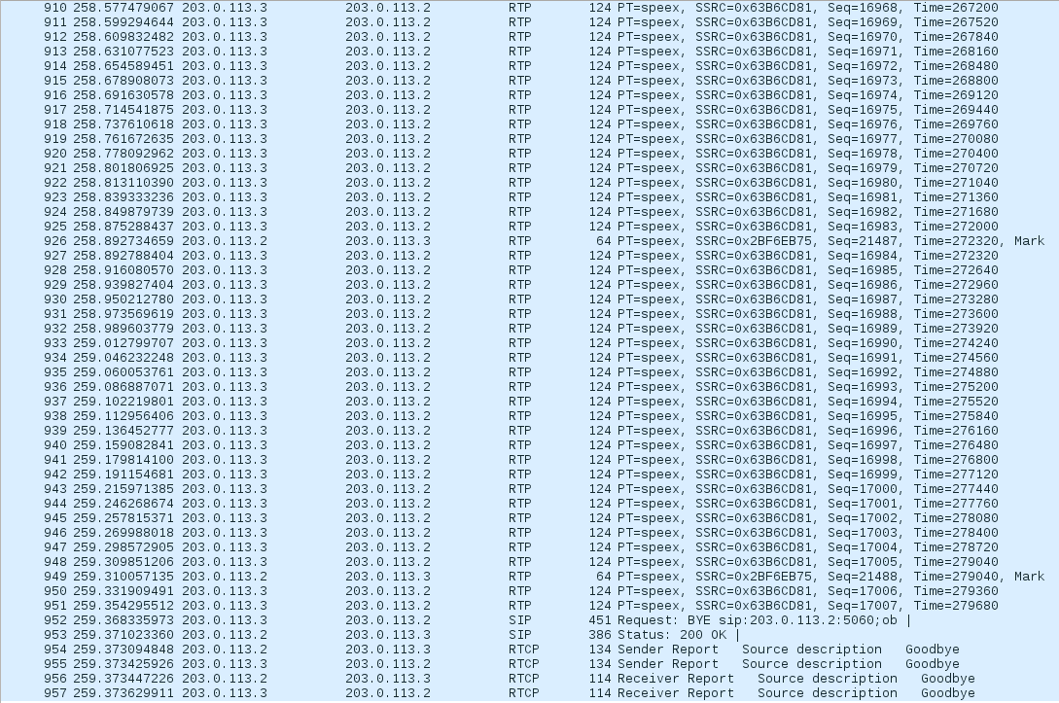


      - Which protocols can you see?
We can see:
- Address Resolution Protocol (ARP)
- Domain Name System (DNS)
- Real Time Protocol (RTP)
- Real Time Control Protocol (RTCP)
- SIP authentication is also visible.
As you can see, there can be hundreds of packets, depending on the time you lasted to finish the call. You will see DNS, SIP, RTP and RTCP packets. Stop the capture and save it in a file, so you can later study packets later.
- First, have a look to the DNS packets (to see only DNS packets, put dns in the Filter box in the left-upper part of wireshark, and press "Apply")
- How many DNS packets can you see?
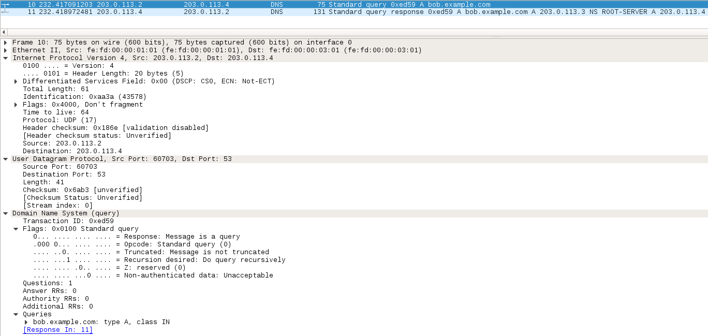
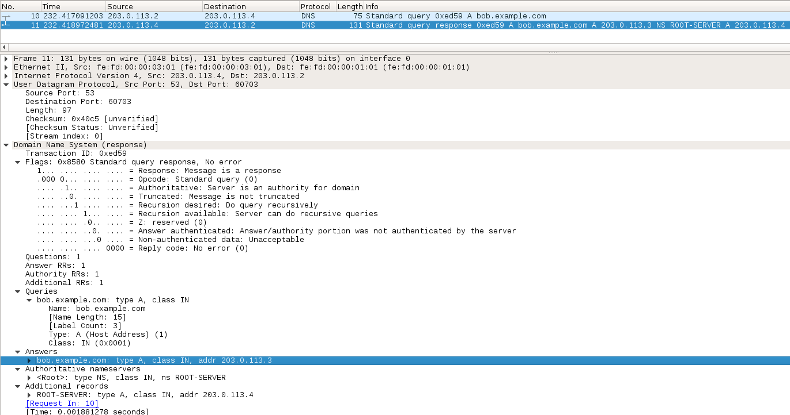
We can see a request and a response
- Who are the origin and destination of these packets?
1st Packet | 2nd Packet
Source: 203.0.113.2  Destination: 203.0.113.4 | Source: 203.0.113.4  Destination: 203.0.113.2

- What is the purpose of these messages?
The purpose of those packets is to know the address for the domain of bob.

1st Packet | 2nd Packet
- Made by Alcie  - To the DNS server to ask which is the address that corresponds to the name bob.example.com | - Made by the DNS Server  - It is an A record that contains the corresponding mapping of Bob.
You will probably see only two DNS packets, a query and a response. The query is made by alice to the DNS server to ask which is the address that corresponds to the name bob.example.com. The DNS sends in the response an A record, that contains the corresponding mapping. Notice that this is the most simplistic exchange of information that you can perform with a DNS server. Later in this lab session, you will have to analyze more complicated dialogues with the DNS, because there are many features of SIP that use the DNS. So, if you do not remember the concepts related to DNS, you had better to review them because we will assume that you know them.
- Now analyze sip packets (filter them using wireshark, as you did with dns packets).
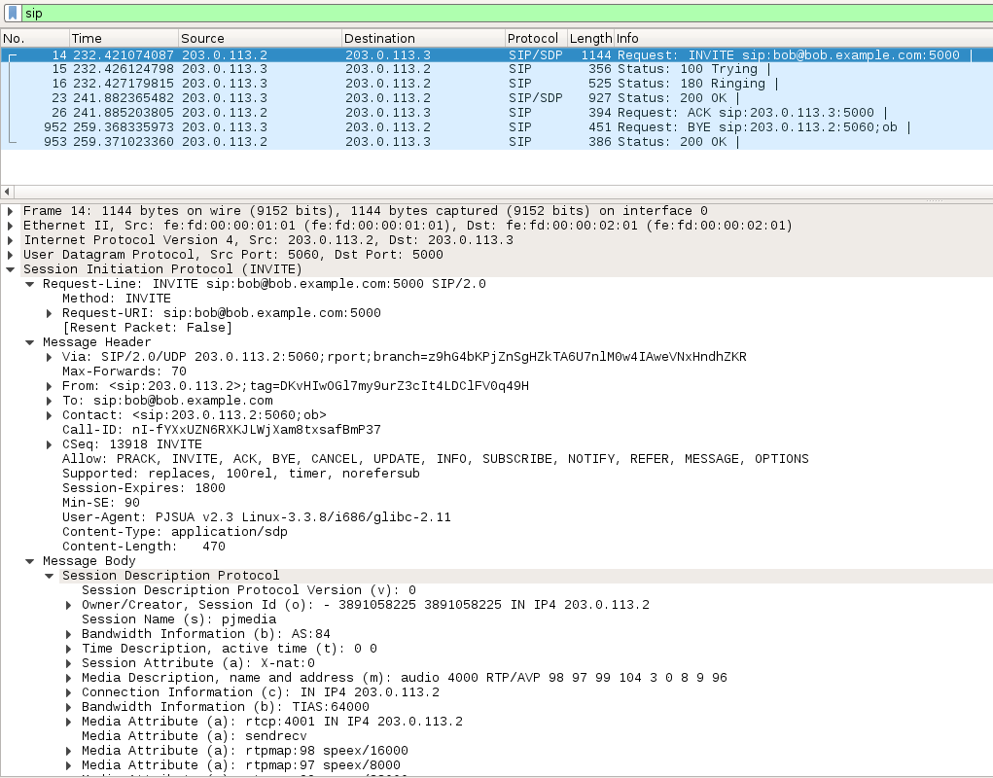
- How many SIP packets can you see?
We can see 7 Packets (2 SIP/SDP and 5 SIP) → Session Description Protocol (SDP)
- Who are the origin and destination of these packets?
See the image, the Origin and destination of the packets are Bob (203.0.113.3) and Alice (203.0.113.2)
- Which of these messages contain SDP information?
The SDP information is seen in packet 14 and 23. They allow the initialization of the SIP session. (Request: Invite and Status 200 OK).
- First SIP packet: The 1st packet send by Alice sending the request INVITE
- Packet send by Bob after typing “h” → informing he wants to stop the tx.
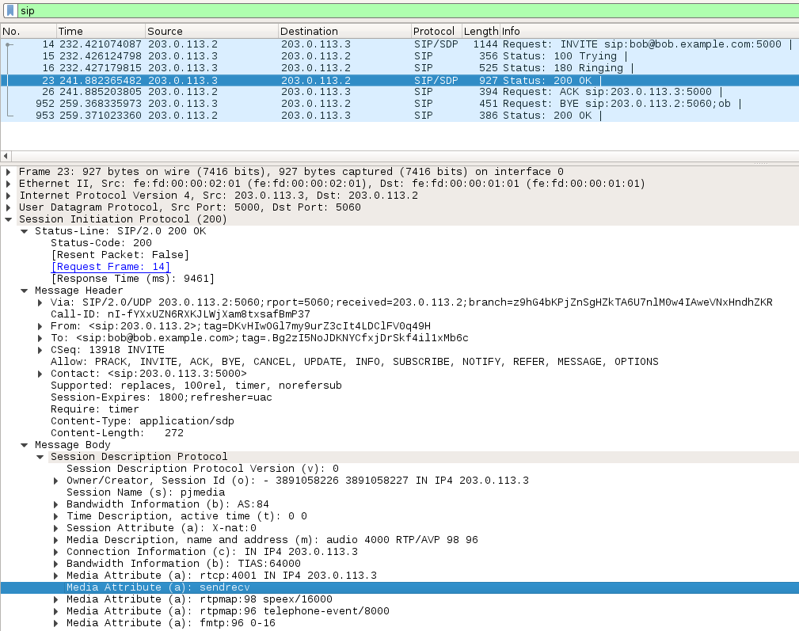
- Describe de dialogue you see.
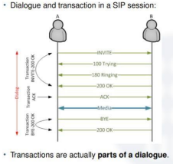
The dialog is:
A → Request: INVITES → BOB
← Status: 100 Trying ←
← Status: 100 Ringing ←
← Status: 200 OK ←
.
.
.
→ Request: ACK →
← Request: BYE ←
→ Status: 200 OK →
- Packet 1: alice request invite bob to join a call in pjsua
- Packet 2: Status 100 packet Typing. Here bob is informing Alice that he received the packet (the invitation) and that he is processing it and doing a search about it.
- Packet 3: Status 180 (Ringing) Then Bob (Destination User Agent) ones the received INVITE has been processed has received the INVITE message and is alerting the user of call (Alice)
- Packet 4: Status OK and then Bob inform that it is okey
- Packet 5: Alice tx and ACK and then she starts tx the file
- Packet 6: The packet is being tx until Bob stops de reception (it could have been alice too) and then it sends a BYE msg to inform about it
Explanation: Transactions and Dialogs IV
- INVITE Transaction:
  - It starts with the INVITE request.
  - It ends with a 200 OK response code (in case of success call).
  - It may have intermediate responses 100 Trying and 180 Ringing.
- ACK Transaction:
  - In general, the ACK has its own transaction (not part of the INVITE transaction).
  - However, when the final response does not have a 2xx code, then the ACK is part of the INVITE transaction.
  - Note that a 3-way handshake (INVITE-OK-ACK) is used to start a session.
  - Next, the media flow is sent between UAs.
- BYE Transaction:
  - To terminate a SIP session, a user ends the call by sending a BYE request
  - The other user responds with a 200 OK response.
- You are now going to see some features that wireshark offers to analyze VoIP calls. Go to menu: Telephony V oIPcalls
→
- How many calls can you see in this view?
We can see 1 call
- Which information can you obtain from this summary? Try to identify what is the meaning of each field.
Source: Alice (203.0.113.2)
From: Alice SIP id over IP
To: SIP address from bob
Protocol: SIP
Duration, Packets, Status and Comments.
As you can see, this view is just a snapshot of the VoIP calls captured by wireshark. In this case, you can see the summary of this only call. The fields represented are:
  - Start Time: Relative time of the start of the call regarding the start of the capture.
  - Stop Time: Relative time of the end of the call regarding the start of the capture.
  - Initial Speaker: IP address of the calling party.
  - From: This corresponds to the information contained in the field “From” of the INVITE.
  - To: This corresponds to the information contained in the field “To” of the INVITE.
  - Packets: Number of packets exchanged during the call.
  - State: Status of the call. Possible values are:
    - CALL SETUP: Setup, Proceeding, Progress or Alerting
    - RINGING: The callee sent the ring tone
    - IN CALL: Call established
    - CANCELLED: Calling party cancelled before establishment.
    - COMPLETED: Call established and ended.
    - REJECTED: Callee canceled before establishment.
    - UNKNOWN: Unknown status of the call.

- Another typical feature of wireshark is showing the dialogue of a call in a graphical way, so go to:
Telephony → V oiPcalls → Selectall → Flow
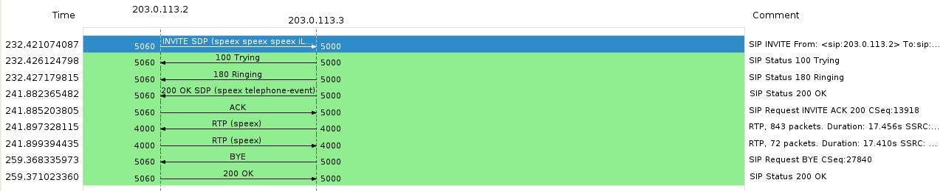
- Can you identify the addresses that exchange SIP packets?
We can see 6 SIP packets: INVITE, STATUS 100 TRYING, STATUS 180 RINGING, STATUS 200 OK, REQUEST BYE, STATUS 200 OK
- Identify the port numbers that are used for each entity and protocol.
ALICE | 203.0.113.2 | BOB | 203.0.113.3
PROTOCOL | PORT | PROTOCOL | PORT
SIP | 5060 | SIP | 5000
RTP | 4002 | RTP | 4002
As you can see, this view shows the time graph of the call. In this particular case, there are only two partici- pants, but there can be up to 10 columns, each one representing the IP address of one of the principals. Each conversation uses a different color, and the arrows show the direction of each packet. Another particular feature of this view is that the RTP traffic is summarized in a bigger arrow.
- Anyway, if you want to see the complete SIP dialogue, with much more information about packets and headers, there is another view. Click on the packet that corresponds to the INVITE method and select:
Analyze → FollowUDPStream
This view shows to you all the SIP dialogue. Save this dialogue in ASCII mode in a file (for instance in the Desktop folder), and open it.
INVITE sip:bob@bob.example.com:5000 SIP/2.0
Via: SIP/2.0/UDP 203.0.113.2:5060;rport;branch=z9hG4bKPjZnSgHZkTA6U7nlM0w4IAweVNxHndhZKR
Max-Forwards: 70
From: <sip:203.0.113.2>;tag=DKvHIwOGl7my9urZ3cIt4LDClFV0q49H
To: sip:bob@bob.example.com
Contact: <sip:203.0.113.2:5060;ob>
Call-ID: nI-fYXxUZN6RXKJLWjXam8txsafBmP37
CSeq: 13918 INVITE
Allow: PRACK, INVITE, ACK, BYE, CANCEL, UPDATE, INFO, SUBSCRIBE, NOTIFY, REFER, MESSAGE, OPTIONS
Supported: replaces, 100rel, timer, norefersub
Session-Expires: 1800
Min-SE: 90
User-Agent: PJSUA v2.3 Linux-3.3.8/i686/glibc-2.11
Content-Type: application/sdp
Content-Length: 470

v=0
o=- 3891058225 3891058225 IN IP4 203.0.113.2
s=pjmedia
b=AS:84
t=0 0
a=X-nat:0
m=audio 4000 RTP/AVP 98 97 99 104 3 0 8 9 96
c=IN IP4 203.0.113.2
b=TIAS:64000
a=rtcp:4001 IN IP4 203.0.113.2
a=sendrecv
a=rtpmap:98 speex/16000
a=rtpmap:97 speex/8000
a=rtpmap:99 speex/32000
a=rtpmap:104 iLBC/8000
a=fmtp:104 mode=30
a=rtpmap:3 GSM/8000
a=rtpmap:0 PCMU/8000
a=rtpmap:8 PCMA/8000
a=rtpmap:9 G722/8000
a=rtpmap:96 telephone-event/8000
a=fmtp:96 0-16
SIP/2.0 100 Trying
Via: SIP/2.0/UDP 203.0.113.2:5060;rport=5060;received=203.0.113.2;branch=z9hG4bKPjZnSgHZkTA6U7nlM0w4IAweVNxHndhZKR
Call-ID: nI-fYXxUZN6RXKJLWjXam8txsafBmP37
From: <sip:203.0.113.2>;tag=DKvHIwOGl7my9urZ3cIt4LDClFV0q49H
To: <sip:bob@bob.example.com>
CSeq: 13918 INVITE
Content-Length: 0

SIP/2.0 180 Ringing
Via: SIP/2.0/UDP 203.0.113.2:5060;rport=5060;received=203.0.113.2;branch=z9hG4bKPjZnSgHZkTA6U7nlM0w4IAweVNxHndhZKR
Call-ID: nI-fYXxUZN6RXKJLWjXam8txsafBmP37
From: <sip:203.0.113.2>;tag=DKvHIwOGl7my9urZ3cIt4LDClFV0q49H
To: <sip:bob@bob.example.com>;tag=.Bg2zI5NoJDKNYCfxjDrSkf4il1xMb6c
CSeq: 13918 INVITE
Contact: <sip:203.0.113.3:5000>
Allow: PRACK, INVITE, ACK, BYE, CANCEL, UPDATE, INFO, SUBSCRIBE, NOTIFY, REFER, MESSAGE, OPTIONS
Content-Length: 0

SIP/2.0 200 OK
Via: SIP/2.0/UDP 203.0.113.2:5060;rport=5060;received=203.0.113.2;branch=z9hG4bKPjZnSgHZkTA6U7nlM0w4IAweVNxHndhZKR
Call-ID: nI-fYXxUZN6RXKJLWjXam8txsafBmP37
From: <sip:203.0.113.2>;tag=DKvHIwOGl7my9urZ3cIt4LDClFV0q49H
To: <sip:bob@bob.example.com>;tag=.Bg2zI5NoJDKNYCfxjDrSkf4il1xMb6c
CSeq: 13918 INVITE
Allow: PRACK, INVITE, ACK, BYE, CANCEL, UPDATE, INFO, SUBSCRIBE, NOTIFY, REFER, MESSAGE, OPTIONS
Contact: <sip:203.0.113.3:5000>
Supported: replaces, 100rel, timer, norefersub
Session-Expires: 1800;refresher=uac
Require: timer
Content-Type: application/sdp
Content-Length: 272

v=0
o=- 3891058226 3891058227 IN IP4 203.0.113.3
s=pjmedia
b=AS:84
t=0 0
a=X-nat:0
m=audio 4000 RTP/AVP 98 96
c=IN IP4 203.0.113.3
b=TIAS:64000
a=rtcp:4001 IN IP4 203.0.113.3
a=sendrecv
a=rtpmap:98 speex/16000
a=rtpmap:96 telephone-event/8000
a=fmtp:96 0-16
ACK sip:203.0.113.3:5000 SIP/2.0
Via: SIP/2.0/UDP 203.0.113.2:5060;rport;branch=z9hG4bKPjBqZi40tMNX6Z69IzYjqR81WVVfS9k5RV
Max-Forwards: 70
From: <sip:203.0.113.2>;tag=DKvHIwOGl7my9urZ3cIt4LDClFV0q49H
To: sip:bob@bob.example.com;tag=.Bg2zI5NoJDKNYCfxjDrSkf4il1xMb6c
Call-ID: nI-fYXxUZN6RXKJLWjXam8txsafBmP37
CSeq: 13918 ACK
Content-Length: 0
BYE sip:203.0.113.2:5060;ob SIP/2.0
Via: SIP/2.0/UDP 203.0.113.3:5000;rport;branch=z9hG4bKPj.eHToCAX5ME7dIBxSj6nQWRUREIDsqjO
Max-Forwards: 70
From: <sip:bob@bob.example.com>;tag=.Bg2zI5NoJDKNYCfxjDrSkf4il1xMb6c
To: <sip:203.0.113.2>;tag=DKvHIwOGl7my9urZ3cIt4LDClFV0q49H
Call-ID: nI-fYXxUZN6RXKJLWjXam8txsafBmP37
CSeq: 27840 BYE
User-Agent: PJSUA v2.3 Linux-3.3.8/i686/glibc-2.11
Content-Length: 0
SIP/2.0 200 OK
Via: SIP/2.0/UDP 203.0.113.3:5000;rport=5000;received=203.0.113.3;branch=z9hG4bKPj.eHToCAX5ME7dIBxSj6nQWRUREIDsqjO
Call-ID: nI-fYXxUZN6RXKJLWjXam8txsafBmP37
From: <sip:bob@bob.example.com>;tag=.Bg2zI5NoJDKNYCfxjDrSkf4il1xMb6c
To: <sip:203.0.113.2>;tag=DKvHIwOGl7my9urZ3cIt4LDClFV0q49H
CSeq: 27840 BYE
Content-Length: 0
- Let us first have a look to the INVITE message:
- Is the INVITE message a Request or a Response?
It is a REQUEST message
- Is this INVITE message following the format described in the theoretical lectures (Start line+Headers+Empty line+Body).
Yes, see message above. (1st message see underlined in yellow 1st and last line)
- In the start line of the INVITE (also known as request line), what do you see? Can you identify the method of this message? And the SIP URI? And the version of the protocol?
INVITE sip:bob@bob.example.com:5000 SIP/2.0
INVITE = TYPE, sip:bob@bob.example.com → Address, 5000 = port, SIP/2.0 → Protocol version :)
We see:
- The method INVITE
- The SIP URI → in charge f the routing of the request: host@+ its port
- The SIP version used
- METHOD: INVITE
- SIP URI: bob@bob.example.com:5000
- Version: SIPvs2.
As you can see, INVITE is the first request message sent by the SIP client, and the start line contains a lot of relevant information. Notice that INVITE is the method, and the SIP URI is responsible for the routing of this request.
Now let us analyze some of the headers:
- Have a look to the Via header, as there are some important fields. Can you identify them?
Via: SIP/2.0/UDP 203.0.113.2:5060;rport;branch=z9hG4bKPjQ6ZfpbLe12max0cp1Ek-qoNqZuwBKNqU
Protocol / Version / Tx protocol / address of the original / and original port / then the branch is presented :)
FIRST HEADER TO APPEAR in SIP msg after the start line
- There may appear several Via headers in a message
- Used to
  - IDENTIFY TRANSACTIONS 14
  - IDENTIFY ROUTE RESPONSES
  - AVOID LOOPS
- Each via header contains:
  - SIP version and Transport protocol
  - The URI of a SIP entity that forwarded that SIP message (previous hops) @Sender and port
  - branch → random string in the branch parameter It is used as a transaction identifier
- Important fields in our VIA HEADER:
  - SIP version and Transport protocol
  - The URI of a SIP entity that forwarded that SIP message
  - “report” field → allows a client to request that the server send the response back to the source IP address and port from which the request originated.
- What is the transport protocol used for SIP in this particular case?
As can be seen in VIA → UDP

- What do you think the branch field is? Is this branch value repeated in other messages? (You can make a search of this value in the text file).
The value that identifies a transaction , UNIQUE identifier of a transaction. Yes during the same transaction, after the transaction finishes, the branch tag is changed :)
Notice:
1st transaction: branch=z9hG4bKPjQ6ZfpbLe12max0cp1Ek-qoNqZuwBKNqU
2nd transaction: branch=z9hG4bKPjuMSkr0aOO28Xszrs.f0iWrBsDQHZi5hk
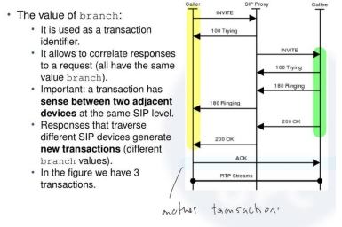
- BRANCH FIELD: is an identifier. It identifies a transaction unambiguously in the via header It is repeated in other messages all the packets from the same.
- Transaction: REQUEST/RESPONSE conversation between two adjacent SIP entities. IN our case.
Remember: Transactions through “adjacent nodes”!! One transaction in GREEN and another one in YELLOW

INVITE is the first message of the first transaction to open a SIP session (a transaction is a request/response conversation between two adjacent SIP entities), and in our particular case is formed by INVITE, Trying, Ring- ing and 200 OK. The branch field contains the identifier of the transaction. Try to locate other transactions in this call, as they will have a different branch value.
- Have a look now to the From, To and Call-ID headers:
From: <sip:203.0.113.2>;tag=RInxFit6M.wPutSo3pbhNgyoWlctJ7cD
To: sip:bob@bob.example.com
Contact: <sip:203.0.113.2:5060;ob>
Call-ID: H7060eGbxStY4XofYfQ21s7YSyD1ePdf
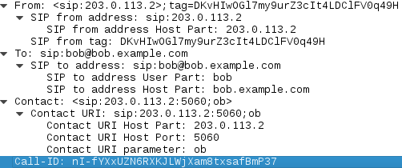
- What information is contained in these headers?
- MANDATORIES N EACH SIP REQUEST.
- FROM and TO → identify the sender and the receiver (respectively) of a request
  - With the CALL-ID identifies unambiguously a SIP dialog
  - THEY identity the ends of a dialog
  - NOT TO ROUTE MSG → doesn’t contain the port
  - OJO! → THE RESPONSE OF THE REQUEST WILL HAVE THE SAME FROM
- CallID → it is used uniquely to identify a call bw the two user agents.
- Are the values of From and To changing in the following SIP messages?
No, because they are from the same call.
- And the tag field?
The TAG field is maintained. NO CHANGE. It is a randomly generated value in the header FROM when a dialog is established.
- Is the value of the Call-ID header repeated in other SIP messages?
Yes, in all headers are the same during the same session.
Notice that To and From contain information related to who the sender and receiver of this request are. How- ever, they are not used to route the request (requests are routed using the SIP URI of the start line). In the request, they are used to fully identify the dialogue. All the messages involved in a call form a dialogue, which is identified unambiguously by To, From and Call-ID.
- There are many other headers available in the INVITE message, but now we are not going to describe them. Have a look to the Message Body.
- Can you see a SDP description in this Message Body? Which are the media proposed by the client (m=) in the INVITE request?
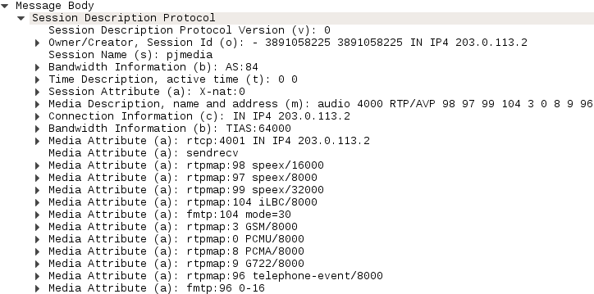
- SDP is not a protocol itself
- Like a “Description protocol”
- Provides general description of session including:
  - Media details
  - Transport protocol
  - @ + other properties
  - User information
  - Session metadata
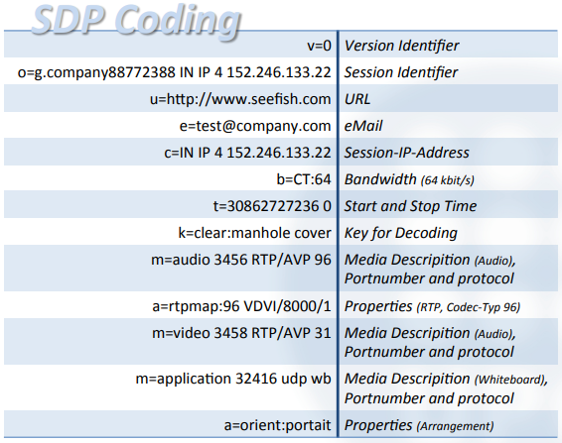
GLOBAL
INFO
DIFFERENT MEDIA
Information given by WIRESHARK
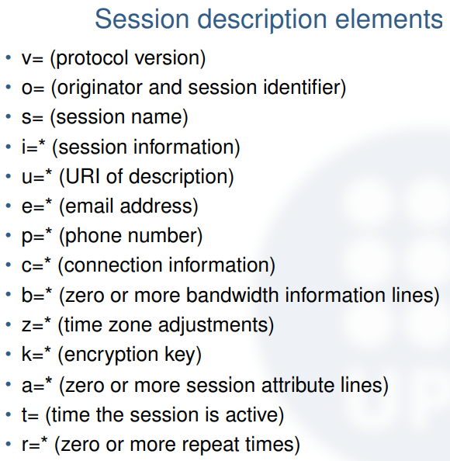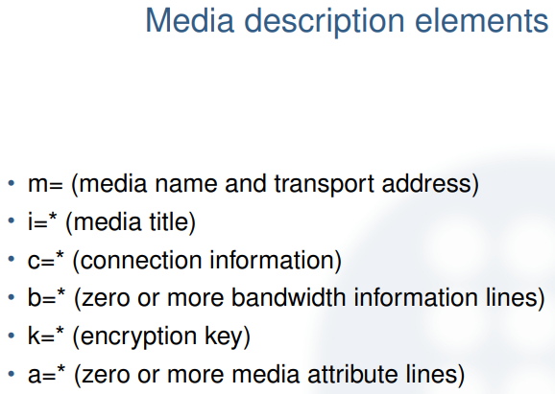
In the message body a SDP profile is transmitted to inform the server about the preferred media to be used. In this particular case, the client propose a list of audio codecs:
m= a u d i o 4000 RTP / AVP 8 98 97 104 3 0 99 9 96
And later a clarification about which are particularly these codecs:
a= r tpmap : 8 PCMA/ 8000
a= r tpmap : 9 8 speex / 16000 a= r tpmap : 9 7 speex / 8000 a= r tpmap : 10 4 iLBC / 8000
a=fmtp : 10 4 mode=30
a= r tpmap : 3 GSM/ 8000
a= r tpmap : 0 PCMU/ 8000
a= r tpmap : 9 9 speex / 32000
a= r tpmap : 9 G722 / 8000
a= r tpmap : 9 6 t e l e p h o n e −e v e n t / 8000
a=fmtp : 9 6 0−16
As you can see, the PCMA/8000 codec is the preferred one (remember you changed this configuration in a previous step in pjsua).
- Have a look to the messages following the INVITE. Have a look to the Trying message:
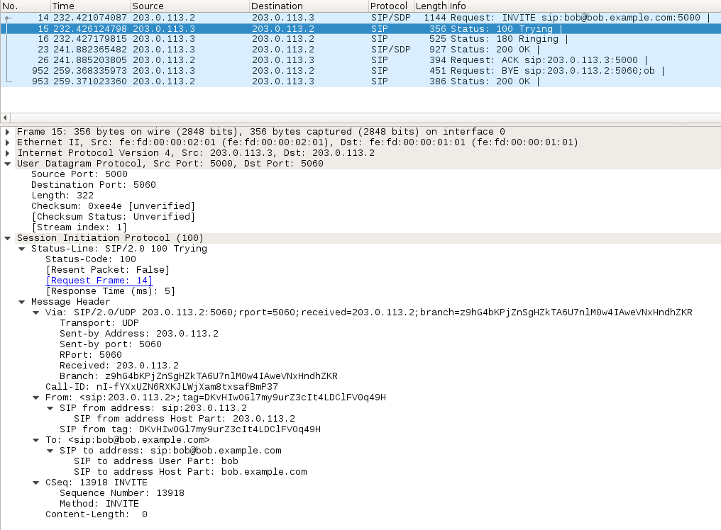
Message content in the trying by using Analyze in UDP Stream WIRESHARK
SIP/2.0 100 Trying
Via: SIP/2.0/UDP 203.0.113.2:5060;rport=5060;received=203.0.113.2;branch=z9hG4bKPjZnSgHZkTA6U7nlM0w4IAweVNxHndhZKR
Call-ID: nI-fYXxUZN6RXKJLWjXam8txsafBmP37
From: <sip:203.0.113.2>;tag=DKvHIwOGl7my9urZ3cIt4LDClFV0q49H
To: <sip:bob@bob.example.com>
CSeq: 13918 INVITE
Content-Length: 0
- Is Trying a request or a response message?
It is a response message.
- Which is the code for the Trying messages? According to this code, which kind of response is this message (Provisional, Success, Redirection, etc.)
The code for the Trying message is 100. This code is a PROVISIONAL code response. All 1XX codes are provisional responses. 100 corresponds to trying.
- Do you know any other application layer protocol that use these text codes for messages, for instance [404 - Not Found]?
The 404 - Not Found corresponds to HTTP which is an application layer protocol that uses text codes for messages.
- Is Trying part of the same transaction than INVITE? How do you know that?
Yes they are from the same transaction. Trying is responding to the INVITE
Trying is a provisional response that indicates that the request has been received by the next-hop and some time is necessary to perform an action (like consulting a database). Provisional Responses may appear or not in a dialogue. As you can see, the first line of response messages include the SIP version and a code. This syntax is similar to that of HTTP.
- Now, have a look to the Ringing message:
SIP/2.0 180 Ringing
Via: SIP/2.0/UDP 203.0.113.2:5060;rport=5060;received=203.0.113.2;branch=z9hG4bKPjZnSgHZkTA6U7nlM0w4IAweVNxHndhZKR
Call-ID: nI-fYXxUZN6RXKJLWjXam8txsafBmP37
From: <sip:203.0.113.2>;tag=DKvHIwOGl7my9urZ3cIt4LDClFV0q49H
To: <sip:bob@bob.example.com>;tag=.Bg2zI5NoJDKNYCfxjDrSkf4il1xMb6c
CSeq: 13918 INVITE
Contact: <sip:203.0.113.3:5000>
Allow: PRACK, INVITE, ACK, BYE, CANCEL, UPDATE, INFO, SUBSCRIBE, NOTIFY, REFER, MESSAGE, OPTIONS
Content-Length: 0

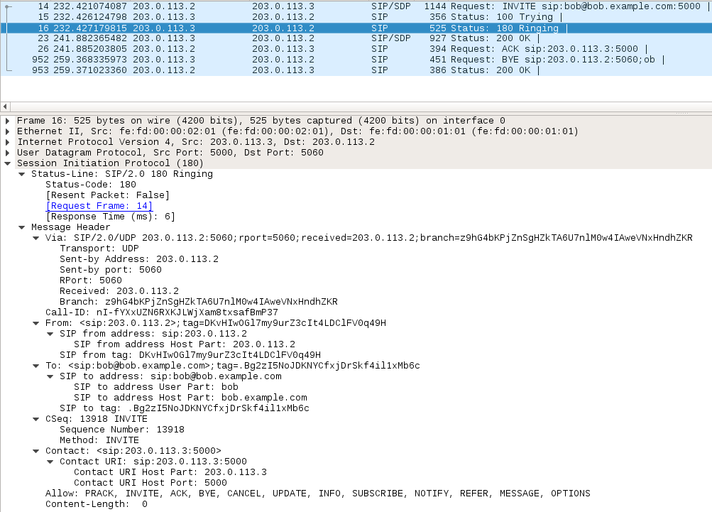
- Request or response? Type of response? Which code? Same transaction?
It is a response. It is a PROVISIONAL response. CODE 180. Destination user agent received INVITE and is alerting the user of the call. Yes, it is the same transaction.
- Which are the differences with the previous message Trying?
- Trying and Ringing are both provisional response message (1xx). The differences are that:
- 100 Trying are optional. Sip User Agent Servers (YAS) generally responds with a 100 Typing response immediately when they receive and INVITE request to let he User Agent Client (UAC) knows they are processing the request → To avoid retransmits.
- 180 Ringing is usually sent when the destination UA receives the INVITE and it is trying to alert the user.
- In the Allow header, what can you see?
- Allow: PRACK, INVITE, ACK, BYE, CANCEL, UPDATE, INFO, SUBSCRIBE, NOTIFY, REFER, MESSAGE, OPTIONS.
- We can see a list of the methods (requests) that the UA is able to understand.
The Ringing message is another provisional response that is usually sent when the destination UA receives the INVITE and it is trying to alert the user. The Allow header is used by one UA to inform the other UA about the methods (requests) that is able to understand.
- Have a look to the following message OK:
SIP/2.0 200 OK
Via: SIP/2.0/UDP 203.0.113.2:5060;rport=5060;received=203.0.113.2;branch=z9hG4bKPjZnSgHZkTA6U7nlM0w4IAweVNxHndhZKR
Call-ID: nI-fYXxUZN6RXKJLWjXam8txsafBmP37
From: <sip:203.0.113.2>;tag=DKvHIwOGl7my9urZ3cIt4LDClFV0q49H
To: <sip:bob@bob.example.com>;tag=.Bg2zI5NoJDKNYCfxjDrSkf4il1xMb6c
CSeq: 13918 INVITE
Allow: PRACK, INVITE, ACK, BYE, CANCEL, UPDATE, INFO, SUBSCRIBE, NOTIFY, REFER, MESSAGE, OPTIONS
Contact: <sip:203.0.113.3:5000>
Supported: replaces, 100rel, timer, norefersub
Session-Expires: 1800;refresher=uac
Require: timer
Content-Type: application/sdp
Content-Length: 272

v=0
o=- 3891058226 3891058227 IN IP4 203.0.113.3
s=pjmedia
b=AS:84
t=0 0
a=X-nat:0
m=audio 4000 RTP/AVP 98 96
c=IN IP4 203.0.113.3
b=TIAS:64000
a=rtcp:4001 IN IP4 203.0.113.3
a=sendrecv
a=rtpmap:98 speex/16000
a=rtpmap:96 telephone-event/8000
a=fmtp:96 0-16
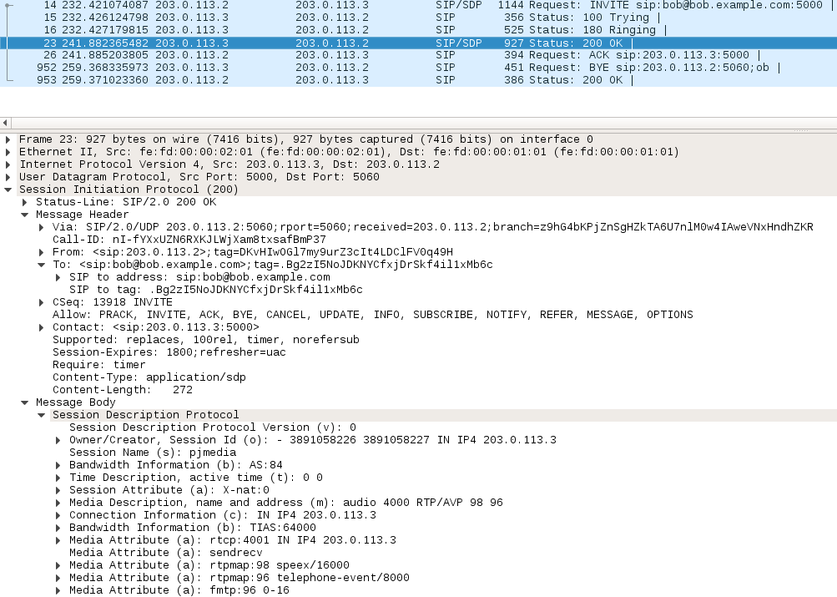
- Request or response? Type of response? Which code? Same transaction?
It is a RESPONSE. It is a SUCCESS response. The code is 200 OK. And it corresponds to the the SAME transaction. It is from the same transaction as it has the same branch than the previous packet in the Via Header.
- 2XX: Success responses that indicate acceptance of the request method.
- 2XX usual response codes:
  - 200: OK
  - 202: Accepted (used with the REFER method).
- Are the methods supported by alice the same than the ones of bob?
Yes, at the beginning they agreed on the messages to be supported. Both methods are supported by Bob and Alice.
- What can you see in the message body of 200 OK?
Information about the session and how the message is going to be send.
- What is finally the media selected for the transmission of the audio?
8 PCMA/8000 codec is selected for the audio.
As you can see 200 OK is the success response, meaning that the INVITE request was successful. After these messages, all the session parameters have been informed to both participants. You can see SDP information inside the message body, stating that finally the 8 PCMA/8000 codec is selected for the audio.
- Have a look to the ACK message:
ACK sip:203.0.113.3:5000 SIP/2.0
Via: SIP/2.0/UDP 203.0.113.2:5060;rport;branch=z9hG4bKPjBqZi40tMNX6Z69IzYjqR81WVVfS9k5RV
Max-Forwards: 70
From: <sip:203.0.113.2>;tag=DKvHIwOGl7my9urZ3cIt4LDClFV0q49H
To: sip:bob@bob.example.com;tag=.Bg2zI5NoJDKNYCfxjDrSkf4il1xMb6c
Call-ID: nI-fYXxUZN6RXKJLWjXam8txsafBmP37
CSeq: 13918 ACK
Content-Length: 0
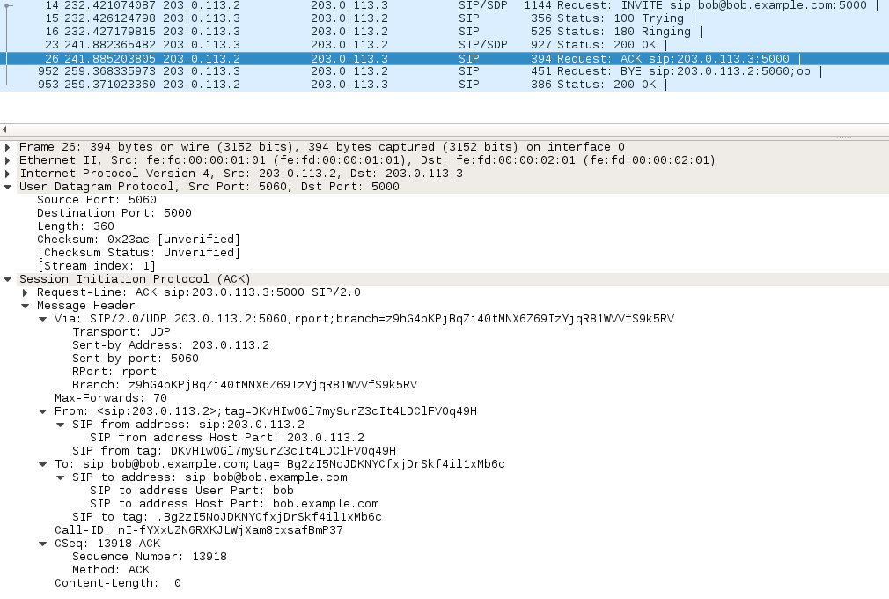
- Request or response? Same transaction?
- ACK atomic message → not considered nor a request nor a response → OJO!
- It is not the same transaction in this case → it has a different branch in the Via Header
- It is the END of the transaction. This is the reason why the branch on the VIA HEADER is different.
The ACK is an atomic message, and it is not considered nor a request nor a response. Depending on if the previ- ous response message is successful or not, ACK could be part of the starting transaction or not. In this particular case in which the request-response exchange has been successful, the ACK message is within a different transac- tion (you can see that it has a different branch), so the starting of a successful session using SIP comprises two transactions (INVITE-OK and ACK). This INVITE-OK-ACK exchange of messages is also called SIP 3-way handshake¹.
- After this SIP 3-way handshake there are other kind of packets, and you will not see them in the file you exported with the SIP dialogue. So return again to the wireshark traces:
- Apart from DNS, SIP and SDP, which other protocols can you see in wireshark?
The other protocols that can be seen are: Real-time Transport Protocol (RTP) and Real-time Transport Control Protocol (RTCP). Also, there are some Address Resolution Protocol (ARP) messages.
- What is the purpose of these protocols?
The purpose of this other protocols are:
- RTP: Transmission of the audio.
- RTCP: Provides some feedback on the transmitted audio.
- What transport protocol do they use? Which are the ports for sender and receiver?
Both RTP and RTCP use User Datagram Protocol (UDP). The ports for the sender and the receiver are:
- RTP: PORT 4000
- RTCP: PORT 4001
- Try to find these port numbers in the SIP 3-way handshake. Do you find them? Where?
On both sides (Alice and Bob) the port of the handshake is 5060. It can be found in the Via Headers of all messages.
You will see in wireshark lots of RTP packets, and some RTCP packets. RTP is intended to transmit the audio, and RTCP to provide some feedback about this audio transmission. RTP and RTCP use UDP as transport pro- tocol, and the ports numbers are informed in the SIP 3-way handshake, using the SDP information of INVITE and OK messages.
- Now have a look to the two ending SIP messages:
BYE sip:203.0.113.2:5060;ob SIP/2.0
Via: SIP/2.0/UDP 203.0.113.3:5000;rport;branch=z9hG4bKPj.eHToCAX5ME7dIBxSj6nQWRUREIDsqjO
Max-Forwards: 70
From: <sip:bob@bob.example.com>;tag=.Bg2zI5NoJDKNYCfxjDrSkf4il1xMb6c
To: <sip:203.0.113.2>;tag=DKvHIwOGl7my9urZ3cIt4LDClFV0q49H
Call-ID: nI-fYXxUZN6RXKJLWjXam8txsafBmP37
CSeq: 27840 BYE
User-Agent: PJSUA v2.3 Linux-3.3.8/i686/glibc-2.11
Content-Length: 0
SIP/2.0 200 OK
Via: SIP/2.0/UDP 203.0.113.3:5000;rport=5000;received=203.0.113.3;branch=z9hG4bKPj.eHToCAX5ME7dIBxSj6nQWRUREIDsqjO
Call-ID: nI-fYXxUZN6RXKJLWjXam8txsafBmP37
From: <sip:bob@bob.example.com>;tag=.Bg2zI5NoJDKNYCfxjDrSkf4il1xMb6c
To: <sip:203.0.113.2>;tag=DKvHIwOGl7my9urZ3cIt4LDClFV0q49H
CSeq: 27840 BYE
Content-Length: 0
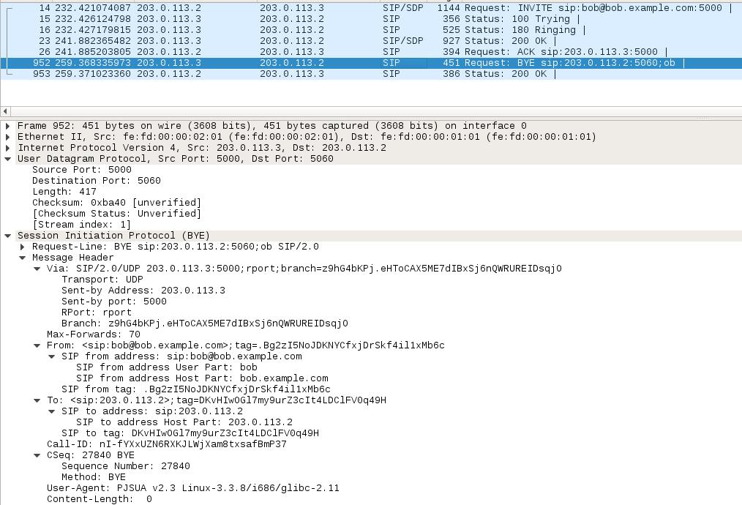
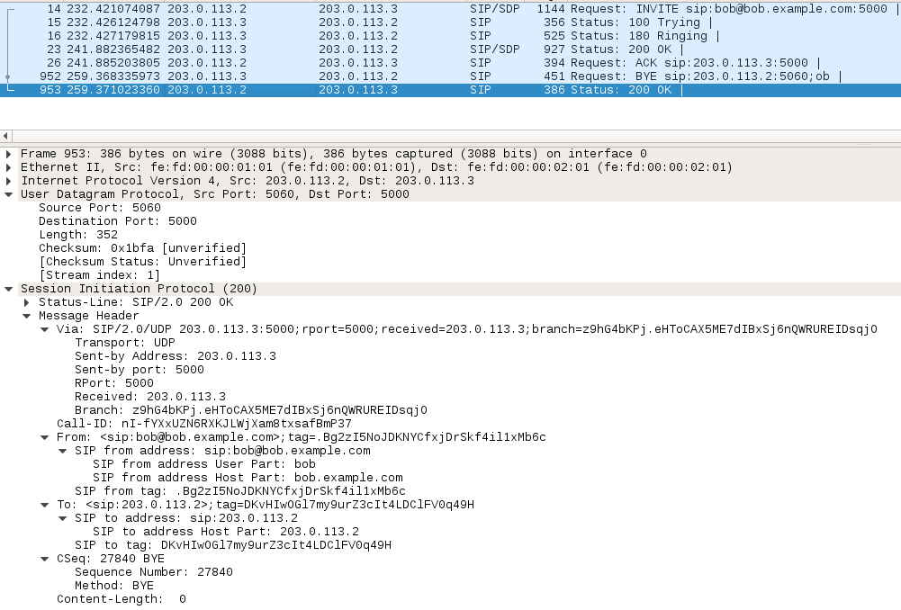
- Which are the messages? Which one is a request, and which is a response?
The messages are: BYE → Request Message and OK → Response Message.
- Are these messages in the same transaction?
Both messages are from the same transaction.
- What is the purpose of these messages? Who finished the call? Do you think that this is the only way of closing a call?
These messages are used to close the session. Ending messages to finish the dialog.
Bob closes the call.
No, Any user could have closed the call. This means that now Bob has closed the call. But Alice could have closed as well. Also, if there is no feedback from one of the sides, the protocol would have ended the session as well.
As you can see, these are the messages used to close a session, and it is enclosed in a single transaction. These are the ending messages to finish the dialogue. Remember which were the fields to identify the transaction (the call) in the SIP headers, and verify that all the previous messages have (almost) the same values in these fields.
- Finally, we are going to listen to the call. Go the the wireshark menu: Telephony V oIP Player Decode Play
→
→ → →
This will allow you to listen to the PCMA flow.
The objective of this first exercise was to get in touch with SIP signaling, so you can know which are the typical packets, fields and values involved to create, maintain and finish a session. In the following exercises you will make some few different calls, and to fully understand them it is necessary you dominate all this previous concepts.

Exercise 1.2–
Now you will test some unsuccessful calls.
1Do not confuse this SIP 3-way handshake with the TCP 3-way handshake (SYN-SYN/ACK-ACK). SIP is an application layer protocol, unlike TCP, which is a transport level protocol. Notice that SIP may or may not use TCP as transport protocol.

- Call bob from alice using option m, but now when introducing the URI of bob do not include the port number:
>>> m
(You currently have 0 calls) Buddy list:
-none-

Choices:
0 For current dialog.
-1 All 0 buddies in buddy list [1 - 0] Select from buddy list
URL An URL
<Enter> Empty input (or 'q') to cancel Make call: sip:bob@bob.example.com

- Wait some seconds, and close the call by typing “h”.

- What SIP messages can you see in wireshark?
- What other messages can you see in wireshark?
- What do you think it is happening?

- Now include again the port number in the call:
>>> m
(You currently have 0 calls) Buddy list:
-none-

Choices:
0 For current dialog.
-1 All 0 buddies in buddy list [1 - 0] Select from buddy list
URL An URL
<Enter> Empty input (or 'q') to cancel Make call: sip:bob@bob.example.com:5000

- Do nothing in bob, just wait a couple of minutes looking at wireshark traces. After this time, type “h” in alice.

- Can you see any new messages? Describe briefly the dialogue.
- What do you think is happening? Think about a telephone call.
- What is the purpose of a CANCEL message? Request or response? Same transaction?
- Who is sending the 487 Request terminated message? Request or response?

- Now do the same previous call, but this time type “h” in the console of bob.

- Can you see any new SIP message? What is the code of that message?
- What do you think is happening? Think about a telephone call.

There are many other ways of closing a session, and many other dialogues possible, these were just some examples. Feel free to test other kind of calls.

Call with Softphones

Exercise 1.3–
In this exercise we are going to make a call using a softphone, so you can hear the audio. You will see that there are no differences regarding SIP signaling between pjsua and linphone.
- Configure the virtual interface SimNet0 in the HOST machine with this command:
HOST$ sudo ifconfig SimNet0 203.0.113.1/24

- Go the start menu of the HOST machine and open linphone.
First → Install linphone: HOST$ sudo apt install linphone
HOST$ linphone
- Start wireshark in SimNet0.
- Make a call from linphone in HOST to pjsua in bob. Use the IP address (and the proper port number) instead of the DNS name of bob.
- Which is the default port of the linphone client? Execute the following command to see this:
HOST$ netstat -nlp |grep linphone
- Can you tell any difference regarding to the previous calls?
Every softphone has its own characteristics. You can have a look to the configuration parameters of linphone to have an idea.

SIP with Proxies

Scenario
The objective of the following lab exercises is to introduce concepts related to SIP proxies. First of all, stop the previous scenario and start the new one:


prox1
prox2
alice
203.0.113.2
SW0
203.0.113.1
203.0.113.3
DNS
198.51.100.2
router
SW1
198.51.100.1
198.51.100.3
198.51.100.4 bob
Linphone

phyhost

Figure 1.2: Scenario of SIP with proxies

HOST$ simctl sip-basic stop HOST$ simctl sip-2proxies start
This new scenario is depicted in Figure 1.2, and it has the shape of a trapezoid, and clients will use proxies to help them to make calls. These proxies are implemented using the kamailio server.

Configuration of the Kamailio database
Before making calls, we have to configure the kamailio database.
- First, we have to create the database that will store all the information related to authorized users. To do so, execute the following commands in both proxies prox1 and prox2:
prox1# kamdbctl create prox2# kamdbctl create

You will be asked for the password of the root user of mysql. This password does not exists, so just press “Enter”. To finish creating the database, just answer “yes” to all questions in the console.
- Include the SIP users in the corresponding proxy, so they can register and make/receive calls:
prox1# kamctl add alice xxxx
prox2# kamctl add bob xxxx

You will be asked for the password of the user with write permission in the kamailio database. This password is

kamailiorw.
- You can see the information related to these new users:
proxX$ kamctl db show subscriber

Notice that you did not state the domain of the users. However in the properties you can see that there is a by default domain. prox1 has been configured to provide service in the domain example.org and prox2 in the domain example.com.
- Finally, you can start the kamailio servers:
prox1$ service kamailio start prox2$ service kamailio start
We recommend doing this configuration manually (at least once), but you can also use a simctl label kamdb to do so:
HOST$ simctl sip-2proxies exec kamdb

Configuration of name resolution in wireshark
- You are going to configure the name resolution in wireshark, so you can better identify the hosts that ex- change packets. Introduce this contents in the file $HOME/.wireshark/hosts (if the file does not exist, create it):
      - dnsA
      - prox1
      - alice
      - dnsB
      - prox2
      - bob
      - linphone
We create the host file with the information above as follows:
- telem@debian:~$ mkdir .wireshark → create the occult folder
- telem@debian:~$ cd .wireshark
- telem@debian:~/.wireshark$ nano hosts

- Next, open wireshark and go to the menu Edit->Preferences->Name Resolution, and tag Only use the profile “hosts” file and Resolve network (IP) addresses (see Figure 1.3). Save changes an close wireshark for later usage.
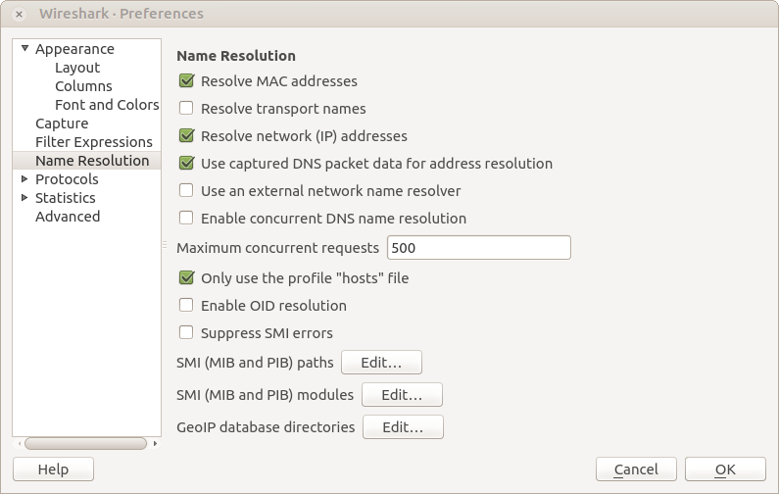

Figure 1.3: Activate a host file for name resolution in wireshark.

Configuration of the DNS servers
It is necessary to configure the DNS service so SIP users can properly register in the proxy servers. To update the DNS server with some new Resource Records (RR), open a console in router (where the DNS service is located) and execute:

router$ nsupdate -k /etc/bind/rndc.key  - update add example.org. 172800 IN NAPTR 30 0 "s" |  |  |  |  | "SIP+D2U" | "" _sip._udp.example.org.
- update add example.org. 172800 | IN | NAPTR 20 0 "s" |  |  | "SIP+D2T" | "" _sip._tcp.example.org.
- update add _sip._udp.example.org. 3600 IN SRV 0 0 5060 prox1.example.org.
- update add _sip._tcp.example.org. 3600 IN SRV 0 0 5060 prox1.example.org.
- send
- update add example.com. 172800 IN |  | NAPTR | 30 0 "s" "SIP+D2U" "" _sip._udp.example.com.
- update add example.com. 172800 IN |  | NAPTR | 20 0 "s" "SIP+D2T" "" _sip._tcp.example.com.
- update add _sip._udp.example.com. | 3600 |  | IN | SRV | 0 0 5060 prox2.example.com.
- update add _sip._tcp.example.com.  - send | 3600 |  | IN | SRV | 0 0 5060 prox2.example.com.
To do this same configuration, you can directly use the label dns.
HOST$ simctl sip-2proxies exec dns
To test that all hosts are able to resolve the new resource records, you can do:
$ dig NAPTR example.org
$ dig SRV _sip._udp.example.org
$ dig prox1.example.org
$ dig NAPTR example.com
$ dig SRV _sip._udp.example.com
$ dig prox2.example.com

Registration process
In this exercise you are going to analyze the registration process of a user in the outbound proxy.
- Start wireshark in SimNet0.
- Start pjsua in alice with this command:
alice$ pjsua --id sip:alice@example.org --registrar sip:example.org \
--realm example.org --username alice --password xxxx --null-audio --auto-play \
--play-file hello16000.wav --auto-answer 180 --outbound sip:example.org \
--add-codec=PCMA/8000 --nameserver=ns1.example.org
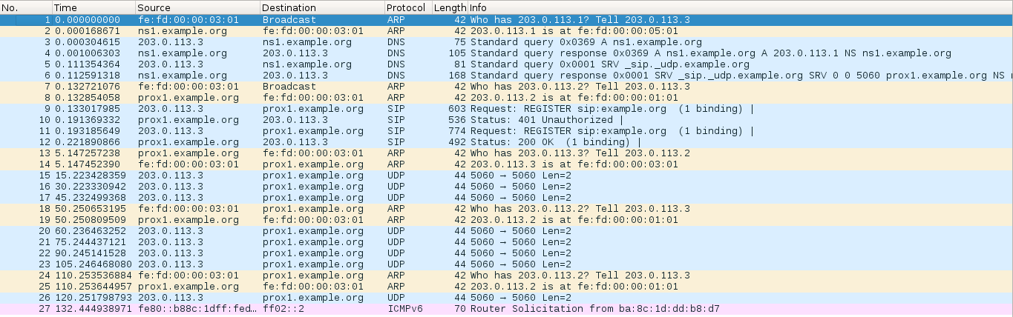
      - Have a look to each of these fields. What is the meaning of the --id? and --registrar, --realm
and --outbound?
SIP Account options:
- –id=url Set the URL of local ID (used in From header)
- –registar=url Set the URL of registar server
SIP Account Auth. Options:
- –relam=string Set realm The realm is used to match this credential against challenges issued by downstream servers. If the realm is not known beforehand, wildcard character ('*') can be specified to make PJSIP respond to any realms
SIP Account Control:
- --outbound=url Set the URL of global outbound proxy server
      - Now have a look to wireshark, and specially to the DNS dialogue. What is the purpose of the first DNS request sent by alice? What is the response to this request?
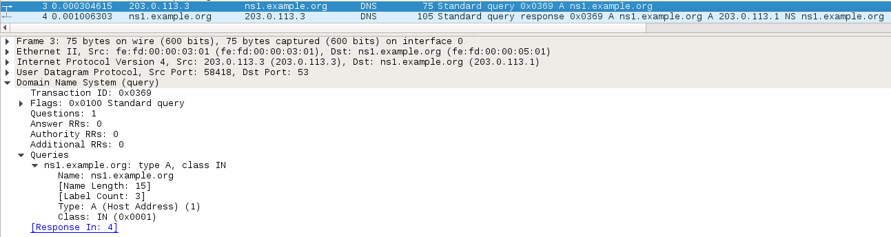
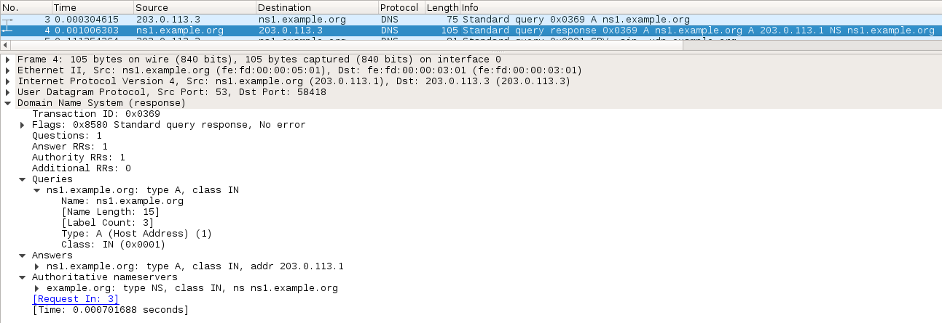
Frame 3: Wants to obtain the register type A of ns1.example.org (it asks for the IPv4) through recursive query. This means that it wants to obtain the final response, not the address of the next name server that he should consult to obtain the response.
- –nameserver=ns1.example.org → done here
Frame 4: frame 1 response → The DNS replies sending the @IP: 203.0.113.1 which is the server itself
Explanation:
Tare two types of queries:
- Iterative: the queried name server returns the address of the next name server that you must consult to obtain the response.
Recursive: the name server tries to find the final response, making several queries to different nameservers if necessary.
      - What is the purpose of the second DNS request sent by alice? What type of RR (Resource Record) is alice asking?
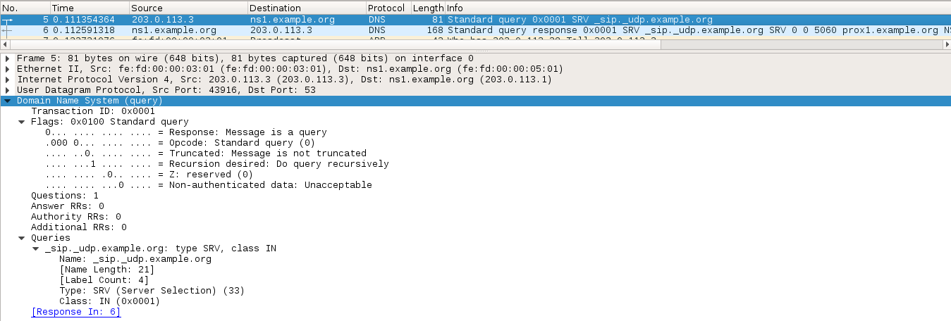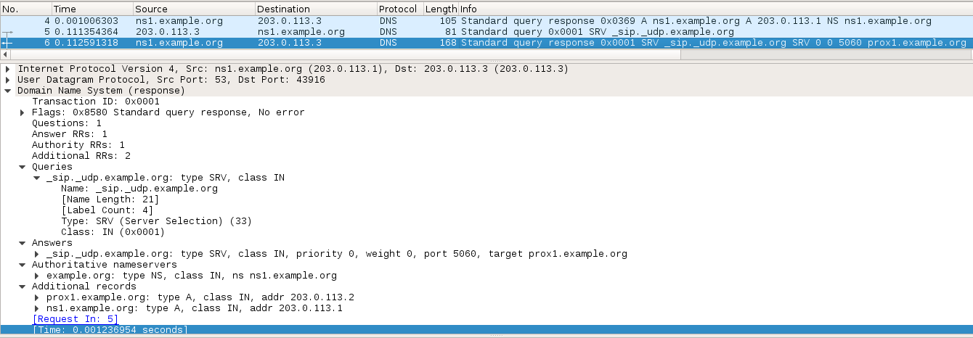
Frame 5: The purpose it is no longer to obtain a @Ipv4 but it is a SRV Record request of _sip_udp.example.org → Alice is asking for the Service Resource Record (SRV) that specifies the location of the servers of a certain service. In this case it asks for the location of the _sip_udp.example.org.
Frame 6: → the response

      - According to this request, what is the transport protocol for the SIP registration when using pjsua? and the domain of usage?
UDP
DOMAIN: The domain is example.org
      - According to the response to the previous query, what is the SIP proxy for alice? Which RR is sending to inform alice about all this information? What is the TTL of this RR?
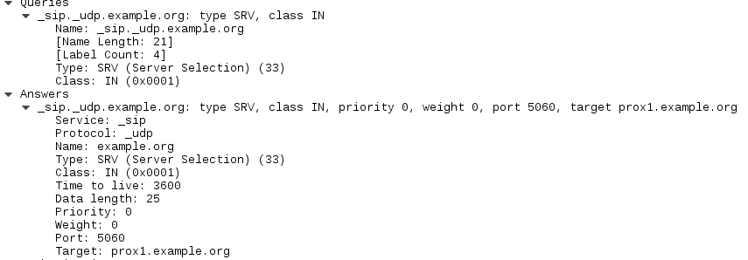
- SIP proxy for alice → prox1.example.org
- RR: SRV
- The RR that is sending this to alice is: ns1.example.org
- The TTL of this is: 3600
      - Is there any other additional RR in this response? Do these RR are of the same type of the previous one? and the TTL?
YES → 2 additional RR
They are both type A o There are Type A RR for prox1.example.org and ns1.example.org with TTL 6000 and NS for the domain name of the Authoritative Name Server also with TTL 6000.
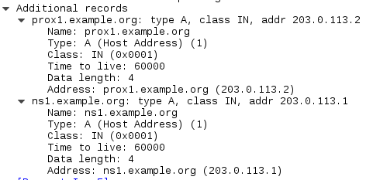
This is a typical DNS dialogue in which the client discovers the outbound proxy by means of the DNS sys- tem. In this case, the client software pjsua first asks for the DNS server in a first query (thanks to the option
--nameserver=ns1.example.org). Once obtained the A record corresponding to this DNS server, pjsua performs a second query asking for a SRV record. As you can see, the current version of pjsua uses UDP as transport protocol for the registration process. This transport protocol may change in other versions of this softphone.

- Now let us continue with the SIP signaling.
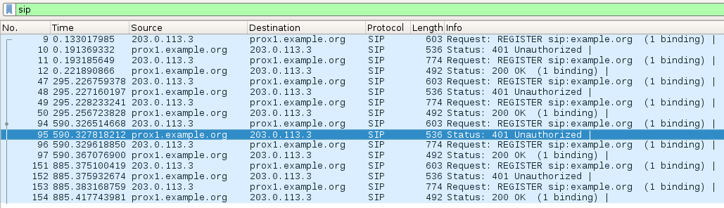
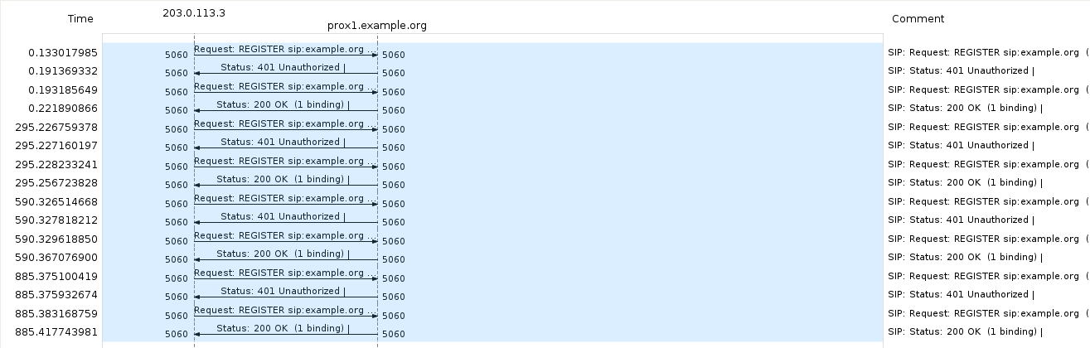
REGISTER sip:example.org SIP/2.0
Via: SIP/2.0/UDP 203.0.113.3:5060;rport;branch=z9hG4bKPjOLeS7FUvSD-SRxoN8KfArz8c3albzogT
Route: <sip:example.org;lr>
Max-Forwards: 70
From: <sip:alice@example.org>;tag=zwe3In6lLBdb8i3G9807uNFe-Du58Xn0
To: <sip:alice@example.org>
Call-ID: M2Qc6H3HIWq9u7j8AXjJKT5Rx0XDBGp.
CSeq: 38503 REGISTER
User-Agent: PJSUA v2.3 Linux-3.3.8/i686/glibc-2.11
Contact: <sip:alice@203.0.113.3:5060;ob>
Expires: 300
Allow: PRACK, INVITE, ACK, BYE, CANCEL, UPDATE, INFO, SUBSCRIBE, NOTIFY, REFER, MESSAGE,
OPTIONS
Content-Length: 0

SIP/2.0 401 Unauthorized
Via: SIP/2.0/UDP 203.0.113.3:5060;rport=5060;branch=z9hG4bKPjOLeS7FUvSD-SRxoN8KfArz8c3albzogT;received=203.0.113.3
From: <sip:alice@example.org>;tag=zwe3In6lLBdb8i3G9807uNFe-Du58Xn0
To: <sip:alice@example.org>;tag=b27e1a1d33761e85846fc98f5f3a7e58.d8d0
Call-ID: M2Qc6H3HIWq9u7j8AXjJKT5Rx0XDBGp.
CSeq: 38503 REGISTER
WWW-Authenticate: Digest realm="example.org", nonce="Y5YMOmOWCw4+vcZbmKydz43asD120IYv"
Server: kamailio (4.2.7 (i386/linux))
Content-Length: 0

REGISTER sip:example.org SIP/2.0
Via: SIP/2.0/UDP 203.0.113.3:5060;rport;branch=z9hG4bKPjsgBEj9VcXapJ3jz12Sa8XOQ1oKOd99cm
Route: <sip:example.org;lr>
Max-Forwards: 70
From: <sip:alice@example.org>;tag=zwe3In6lLBdb8i3G9807uNFe-Du58Xn0
To: <sip:alice@example.org>
Call-ID: M2Qc6H3HIWq9u7j8AXjJKT5Rx0XDBGp.
CSeq: 38504 REGISTER
User-Agent: PJSUA v2.3 Linux-3.3.8/i686/glibc-2.11
Contact: <sip:alice@203.0.113.3:5060;ob>
Expires: 300
Allow: PRACK, INVITE, ACK, BYE, CANCEL, UPDATE, INFO, SUBSCRIBE, NOTIFY, REFER, MESSAGE, OPTIONS
Authorization: Digest username="alice", realm="example.org", nonce="Y5YMOmOWCw4+vcZbmKydz43asD120IYv", uri="sip:example.org", response="9631bd0dabf1a6c3314ee3cea8964fac"
Content-Length: 0

SIP/2.0 200 OK
Via: SIP/2.0/UDP 203.0.113.3:5060;rport=5060;branch=z9hG4bKPjsgBEj9VcXapJ3jz12Sa8XOQ1oKOd99cm;received=203.0.113.3
From: <sip:alice@example.org>;tag=zwe3In6lLBdb8i3G9807uNFe-Du58Xn0
To: <sip:alice@example.org>;tag=b27e1a1d33761e85846fc98f5f3a7e58.4a46
Call-ID: M2Qc6H3HIWq9u7j8AXjJKT5Rx0XDBGp.
CSeq: 38504 REGISTER
Contact: <sip:alice@203.0.113.3:5060;ob>;expires=300
Server: kamailio (4.2.7 (i386/linux))
Content-Length: 0
      - What new SIP method is alice using? What is the purpose of this method? What is the SIP URI of the request line?
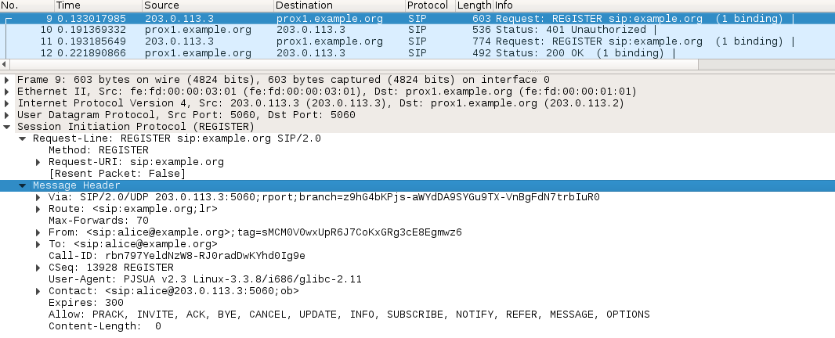
- SIP method: REGISTER
- The purpose of REGISTER: Used by a UA (in this case Alice) to register in a SIP “Register Server”
- URI: example.org
      - In this method, what are the contents of the To and From headers?
From: <sip:alice@example.org>;tag=zwe3In6lLBdb8i3G9807uNFe-Du58Xn0
To: <sip:alice@example.org>

      - Can you see any header indicating an expiry time for this request?
YES! We can see the expire as a header and also the Max-Forwards.
Max-Forwards: 70
Expires: 300
      - What is the response for this first request? Is this response stating success or failure of the request?
SIP/2.0 401 Unauthorized
Via: SIP/2.0/UDP 203.0.113.3:5060;rport=5060;branch=z9hG4bKPjOLeS7FUvSD-SRxoN8KfArz8c3albzogT;received=203.0.113.3
From: <sip:alice@example.org>;tag=zwe3In6lLBdb8i3G9807uNFe-Du58Xn0
To: <sip:alice@example.org>;tag=b27e1a1d33761e85846fc98f5f3a7e58.d8d0
Call-ID: M2Qc6H3HIWq9u7j8AXjJKT5Rx0XDBGp.
CSeq: 38503 REGISTER
WWW-Authenticate: Digest realm="example.org", nonce="Y5YMOmOWCw4+vcZbmKydz43asD120IYv"
Server: kamailio (4.2.7 (i386/linux))
Content-Length: 0
- SIP/2.0 401 Unauthorized
- It is stating failure of the request
- Explanation: This error message means User authentication is required by the responding server or that authorization has been refused for the provided credentials with the request.
      - Does this response include any parameter in the header that should be used for the authentication of the user? Do you remember which is the formula that should be executed for this authentication?
YES → : the field nonce in the WWW_Authenticate header should be used by the UA to prove that he knows the password
Formula:
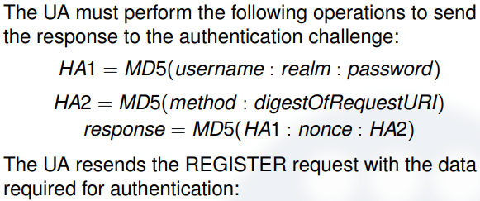
      - Is alice sending a second request? What is the difference of this second request regarding the first one?
REGISTER sip:example.org SIP/2.0
Via: SIP/2.0/UDP 203.0.113.3:5060;rport;branch=z9hG4bKPjsgBEj9VcXapJ3jz12Sa8XOQ1oKOd99cm
Route: <sip:example.org;lr>
Max-Forwards: 70
From: <sip:alice@example.org>;tag=zwe3In6lLBdb8i3G9807uNFe-Du58Xn0
To: <sip:alice@example.org>
Call-ID: M2Qc6H3HIWq9u7j8AXjJKT5Rx0XDBGp.
CSeq: 38504 REGISTER
User-Agent: PJSUA v2.3 Linux-3.3.8/i686/glibc-2.11
Contact: <sip:alice@203.0.113.3:5060;ob>
Expires: 300
Allow: PRACK, INVITE, ACK, BYE, CANCEL, UPDATE, INFO, SUBSCRIBE, NOTIFY, REFER, MESSAGE, OPTIONS
Authorization: Digest username="alice", realm="example.org", nonce="Y5YMOmOWCw4+vcZbmKydz43asD120IYv", uri="sip:example.org", response="9631bd0dabf1a6c3314ee3cea8964fac"
Content-Length: 0
- Yes
- In this request Alice has a parameter with the response proving that she is she. With the nonce and the response for that nonce she calculated (with Hash or whatever). → NONCE = Number Only Used Once
- Explanation: In this request She has a parameter with the response proving that she is she. With the nonce and the response for that nonce she calculated (with Hash or whatever).
      - What is the response code for this second request? What does this mean?
SIP/2.0 200 OK
Via: SIP/2.0/UDP 203.0.113.3:5060;rport=5060;branch=z9hG4bKPjsgBEj9VcXapJ3jz12Sa8XOQ1oKOd99cm;received=203.0.113.3
From: <sip:alice@example.org>;tag=zwe3In6lLBdb8i3G9807uNFe-Du58Xn0
To: <sip:alice@example.org>;tag=b27e1a1d33761e85846fc98f5f3a7e58.4a46
Call-ID: M2Qc6H3HIWq9u7j8AXjJKT5Rx0XDBGp.
CSeq: 38504 REGISTER
Contact: <sip:alice@203.0.113.3:5060;ob>;expires=300
Server: kamailio (4.2.7 (i386/linux))
Content-Length: 0
- SIP/2.0 200 OK
- It means that the register has been authorized.
As you have seen, the REGISTER process when authentication is needed is not so simple. The user sends a REGISTER request to the SIP Registrar proxy. The To and From headers contain the AOR (address of record) of this user. The Expires header specifies the validity period (in seconds) of the registration. The proxy responds with a 401 Unauthorized, which includes a WWW-Authenticate header containing a nonce that will be used to demonstrate that the user knows the corresponding password. After this, the user sends a second REGISTER containing an Authorization header, with the proof of the knowledge of the password. Remember that in the lecture slides you have the formula to verify the validity of these proofs. If the response is correct, the proxy sends a 200 Ok response, meaning that the registration was successful.
If you want to verify that alice is registered in the kamailio server, you can execute:
prox1$kamctl ul show

- Now, you are going to see the dialogue when the registration process fails. To make this, execute the following command in bob, having into account that it contains a wrong password:
bob$ pjsua --id sip:bob@example.com --registrar sip:example.com \
--realm example.com --username bob --password yyyy --null-audio \
--auto-answer 180 --auto-loop --outbound sip:example.com \
--add-codec=PCMA/8000 --nameserver=ns1.example.com
Have a look to the wireshark traces and locate the differences with the previous dialogue.
Before starting the next exercise, make the registering of bob in his proxy, and verify that it is correct.
bob$ pjsua --id sip:bob@example.com --registrar sip:example.com \
--realm example.com --username bob --password xxxx --null-audio \
--auto-answer 180 --auto-loop --outbound sip:example.com \
--add-codec=PCMA/8000 --nameserver=ns1.example.com

Call with Inbound and Outbound Proxies
Now that you understand the basics of DNS and SIP signaling, you are prepared to analyze a call using the classical sip trapezoid. Unlike the previous exercises in which we have guided you during the packet inspection by asking you specific questions, here you are completely free to analyze the traces on your own.
So, just make a call from alice to bob, and try to understand the overall dialogue, just considering these guidelines:
- As you will see, there will be many packets in both SimNet0 and SimNet1, so we recommend to use the filter tool of wireshark.
- Making a picture with the packets involved may help you to understand the dialogue.

- Have a look to packets that are involved in the authentication of the clients.
- Pay attention to the most relevant SIP headers. This includes headers like Via, Contact, Record-Route
and Route.

